International Journal of Precision Engineering and Manufacturing (2024) 1:1-3 Online ISSN 2951-6382 Print ISSN 2951-4614
REGULAR PAPER

Evaluation of Energy Efficiency and Material Removal Rate in Hybrid Manufacturing Processes (Title in English Here, Franklin Gothic Demi Cond 17pt, Bold)

John Green¹ · Kil-Tong Park² · Wei Chang³ (Name in English, Franklin Gothic Demi Cond 12pt)

Received: 15 May 2021 / Revised: 23 August 2021 / Accepted: 16 October 2021 / Published online: 21 December 2021
© Korean Society for Precision Engineering 2023 (Franklin Gothic Demi Cond 9.0pt)

Abstract
Abstract should be written in English using Times New Roman 10pt. Write English abstract here. Write English abstract here. Write English abstract here. Write English abstract here. Write English abstract here. Write English abstract here. Write English abstract here. English abstract here. Write English abstract here. Write English abstract here. Write English abstract here. Write English abstract here. Write English abstract here. Write English abstract here. Write English abstract here. Write English aEnglish abstract here. Write English abstract here. Write English abstract here. Write English abstract here. Write English abstract here. Write English abstract here. Write English abstract here. Write English abstract here. Write English abstract here. Write English abstract here. Write English abstract here. Write English abstract here. Write English abstract here. Write English abstract here.bstract here. Write English abstract here. Write English abstract here. Write English abstract here. Write English abstract here. Write English abstract here. Write English abstract here. Write English abstract here. Write English abstract here. Write English abstract here. Write English abstract here. Write English abstract here. Write English abstract here. Write English abstract here. Write English abstract here. (150 to 250 words) (Times New Roman 10pt)

Keywords Deep reinforcement learning · Energy management strategy · Fuel cell hybrid bus · Smart manufacturing (4 to 6 keywords) (Times New Roman 10pt)

List of Symbols

vw Workpiece Velocity
a Depth of Cut
Ft Tangential Forces per unit Width Fn Normal Forces per unit Width
R Distance between the Pin and Journal Rw Radius of Pin
Rs Radius of Grinding Wheel
P Grinding Point

John Green (Times New Roman 8pt) ijpem.st@kspe.or.kr

1 Key Laboratory of Road Construction Technology and Equipment, Ministry of Education, Chang’an University, Xi’an 710064, China
2 Shantui Construction Machinery Co., Ltd., Jining 272073, China
3 State Key Laboratory for Manufacturing Systems Engineering, Xi’an Jiaotong University, Xi’an 710049, China

Introduction (Franklin Gothic Demi Cond 12pt, Bold)

Contents of the journal should be written in English using Times New Roman 10pt. Contents of the journal should be written in English using Times New Roman 10pt. Contents of the journal should be written in English using Times New Roman 10pt. Contents of the journal should be written in English using Times New Roman 10pt. Contents of the journal should be written in English using Times New Roman 10pt.

Extension of Two-Dimensional Model to the Turning Process (Franklin Gothic Demi Cond 12pt, Bold)

Simulation (Franklin Gothic Demi Cond 11pt, Bold)

Contents of the journal should be written in English using

https//doi.org/-

- / October 2022 International Journal of Precision Engineering and Manufacturing 1(1):2-3 (Myriad Pro 7 pt)

Table 1 Comparison of measured roughness data

Contents of Table
aaa | 0.97 (cc/rev)
bbb | 1 (mm)
ccc | 100 (bar)
ddd | 1.5 × 109 (Pa)

Fig. 1 Block diagram of multi-modal chatter model of a high speed machining center (Times New Roman 9pt)
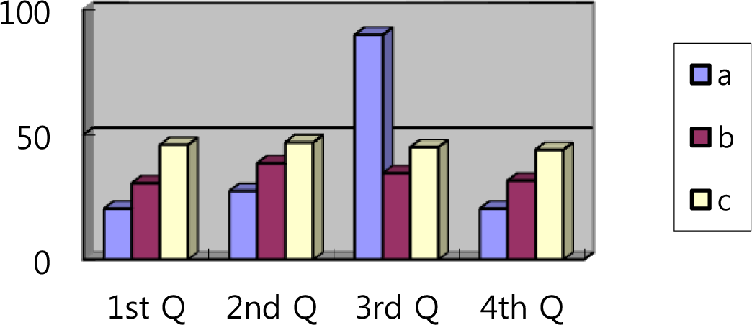
Fig. 2 Diagram of multi-modal chatter model:

Times New Roman 10pt. Contents of the journal should be written in English using Times New Roman 10pt. Contents of the journal should be written in English using Times New Roman 10pt. Contents of the journal should be written in English using Times New Roman 10pt. Contents of the journal should be written in English using Times New Roman 10pt. Contents of the journal should be written in English using Times New Roman 10pt. Contents of the journal should be written in English using Times New Roman 10pt. Contents of the journal should be written in English using Times New Roman 10pt. Contents of the journal should be written in English using Times New Roman 10pt. Contents of the journal should be written in English using Times New Roman 10pt.
R
cd ≈ ----^{m}---^{W}---s (Times New Roman 10pt, Italic) (1)
R eP

written in English using Times New Roman 10pt. Contents of the journal should be written in English using Times New Roman 10pt. Contents of the journal should be written in English using Times New Roman 10pt [1].

Conclusions (Franklin Gothic Demi Cond 12pt, Bold)

Contents of the journal should be written in English using Times New Roman 10pt. Contents of the journal should be written in English using Times New Roman 10pt. Contents of the journal should be written in English using Times New Roman 10pt. Contents of the journal should be written in English using Times New Roman 10pt. Contents of the journal should be written in English using Times New Roman 10pt. Contents of the journal should be written in English using Times New Roman 10pt. Contents of the journal should be written in English using Times New Roman 10pt. Contents of the journal should be written in English using Times New Roman 10pt.

Acknowledgement(s) Contents of the journal should be written in English using Times New Roman 8pt. Contents of the journal should be written in English using Times New Roman 8pt. Contents of the journal should be written in English using Times New Roman 8pt.

eW

where R_{mW} is the mean cone distance of the wheel, and R_{mW} is the outer cone distance of the wheel.

Funding Contents of the journal should be written in English using Times New Roman 8pt.

ab = cd cosβmW

WW = ab – hfmW(tanαcWX + tanαcWV)

Simulation (Franklin Gothic Demi Cond 11pt, Bold)
(2)

(3)
Declarations (11pt)

Conflict of interest (Franklin Gothic Demi Cond 10pt) Contents of the journal should be written in English using Times New Roman 8pt.

Data availability Contents of the journal should be written in English using Times New Roman 8pt.

Contents of the journal should be written in English using Times New Roman 10pt. Contents of the journal should be written in English using Times New Roman 10pt. Contents of the journal should be written in English using Times New Roman 10pt. Contents of the journal should be written in English using Times New Roman 10pt. Contents of the journal should be written in English using Times New Roman 10pt. Contents of the journal should be written in English using Times New Roman 10pt. Contents of the journal should be

Code availability Contents of the journal should be written in English using Times New Roman 8pt.

Ethics approval Contents of the journal should be written in English using Times New Roman 8pt.

Consent to participate Contents of the journal should be written in English using Times New Roman 8pt.

Consent for publication Contents of the journal should be written in English using Times New Roman 8pt.

International Journal of Precision Engineering and Manufacturing 1(1):3-3 October 2022 / 3 (Myriad Pro 7 pt)

References (Franklin Gothic Demi Cond 12pt, Bold)

- Chen, B., Liang, D., Li, Z. (2014). A study on geometry design of spiral bevel gears based on conjugate curves. International Journal of Precision Engineering and Manufacturing, 15(3), 477–482.
- Tlusty, J., Smith, S., Zamudia, C. (1990). Operation planning based on cutting process model. Journal of the Korean Society for Precision Engineering, 39(12), 517–521.
- Rousseeuw, P. J. and Leroy, A. M. (1987). Robust regression and outlier detection. John Wiley & Sons.
- Cheng, K.-Y., Su, Y. Y., Chen, Y.-L., Tai, H.-M., Chou, J.-T. (2005). Fiber optic interferometric sensors for micro-positioning applications. Proceedings of the Third International Conference on Experimental Mechanics and Third Conference of the Asian Committee on Experimental Mechanics, 921-925.
- Eneyew, E. D. (2014). Experimental study of damage and defect detection during drilling of CFRP composites. Ph.D. Thesis. University of Washington.
- ISO 21919-1:2019. (2019). Automation systems and integration — Interfaces for automated machine tending — Part 1: Overview and fundamental principles.

Publisher’s Note Contents of the journal should be written in English using Times New Roman 8pt.

Name (Franklin Gothic Demi Cond 9pt) received Ph.D. candidate in the Department of Mechanical Engineering, Korea University. His/Her research interest is machine. (Times New Roman 9pt)

Name is Professor in the Department of Mechanical Engineering, USA University. His/Her research interest is machine.

